LAB 9
Subqueries
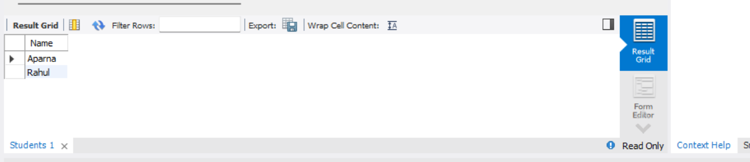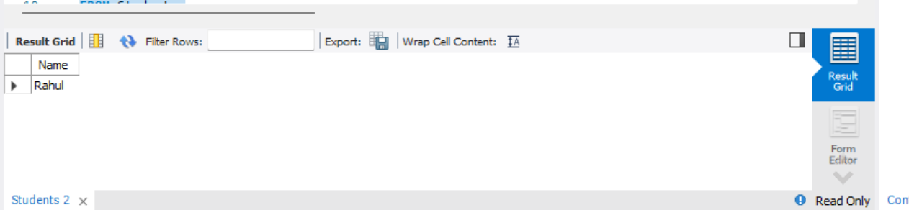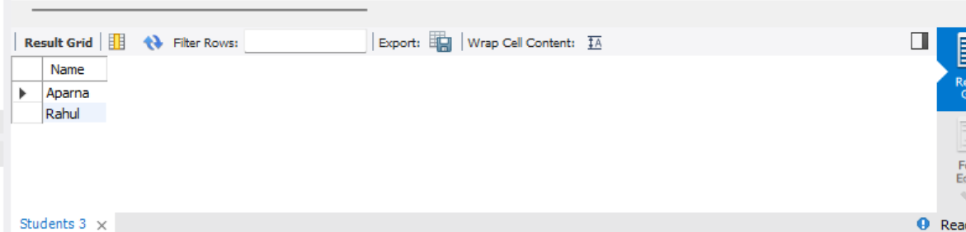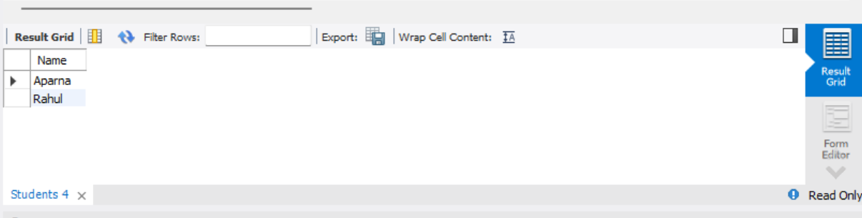

1. IN: Displays the names of students whose StudentID is present in the Courses table.
2. ANY: Displays the names of students whose age is greater than at least one student's age from Chennai.
3. ALL: Displays the names of students whose age is greater than every student's age from Delhi.
4. EXISTS: Displays the names of students who have a matching StudentID in the Courses table.

